VAPT T1 Report — Metasploitable Lab

Scope:
Internal lab assessment of Metasploitable VM (192.168.137.129) from Kali attacker (192.168.137.128) and Windows host (192.168.137.1). This assessment used Nmap, OWASP ZAP, and manual inspection.

Top findings (high level):
- Multiple exposed services with known vulnerable versions (vsftpd 2.3.4, Apache 2.2.8, MySQL 5.0.51, Tomcat 5.5, UnrealIRCd, etc.).
- Web application misconfigurations and missing security headers reported by OWASP ZAP (missing CSP, missing anti-clickjacking header, absence of Anti-CSRF tokens, directory browsing, application error disclosure, vulnerable JS library).
- Presence of legacy/unsafe network services (rsh/rexec, telnet, ftp anonymous) that enable easy privilege escalation in a lab environment.

Scope & Methodology
Scope:
- Target: 192.168.137.129 (Metasploitable VM)
- Attacker: 192.168.137.128 (Kali VM)
- Additional host on network: 192.168.137.1 (Windows)
Methodology:
- Recon & discovery using Nmap.
- Web application analysis using OWASP ZAP (active & passive scans).
- Vulnerability identification via service versions and verification against known CVEs.
- Exploitation with Metasploit in the lab.

Technical Findings (Summary)
Below are consolidated findings from your Nmap output and OWASP ZAP results. Each finding should include Evidence (screenshot / raw output), CVE (if known), CVSS score, Reproducible steps and Remediation.

1 - Anonymous FTP allowed (vsftpd 2.3.4)
Target: 192.168.137.129:21
Severity: Medium-High (depends on data)
Description:
Anonymous FTP login allowed - anonymous access to FTP root. vsftpd 2.3.4 is an outdated version used in Metasploitable.

Evidence:
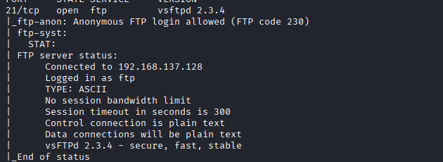

Remediation:
Action taken / recommended:
1. Disable anonymous FTP: edit /etc/vsftpd.conf -> anonymous_enable=NO
2. Restart or remove vsftpd:
sudo systemctl restart vsftpd
or to remove: sudo apt-get remove --purge vsftpd -y
3. Replace FTP with SFTP (SSH) for file transfer; restrict SFTP users using chroot.
Verification:
- Attempt anonymous ftp login (should be refused).
- ls -l /etc/vsftpd.conf

2 - SSH outdated (OpenSSH 4.7p1)
Target: 192.168.137.129:22
Severity: Medium
Description:
Old OpenSSH version; weak host keys observed (DSA/RSA key types).

Evidence:
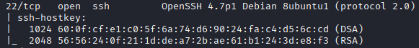

Remediation:
Actions Recommended:
1. Upgrade OpenSSH: sudo apt-get install --only-upgrade openssh-server
2. Remove DSA host keys and regenerate strong keys: sudo rm /etc/ssh/ssh_host_dsa_key*; sudo ssh-keygen -A
3. Harden /etc/ssh/sshd_config: PermitRootLogin no; PasswordAuthentication no; set strong ciphers/KEX.
4. Restart SSH: sudo systemctl restart ssh
Verification: ssh -V; sudo sshd -T | grep -E 'permitrootlogin|passwordauthentication'

3 - Telnet and rsh services (cleartext credentials)
Target: 192.168.137.129:23,512-514
Severity: High
Description:
Telnet, rexecd and rshd allow cleartext credential transmission; trivial to intercept and reuse in lab.

Evidence:
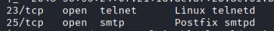

Remediation:
Action recommended:
1. Remove telnet/rsh packages: sudo apt-get remove --purge telnetd rsh-server -y
2. Remove xinetd configs that invoke these services: sudo rm -f /etc/xinetd.d/telnet /etc/xinetd.d/rsh
3. Restart xinetd: sudo service xinetd restart
Verification: ss -tulpn | egrep ':(23|512|513|514)\s'

4 - Apache HTTPD 2.2.8 & Directory browsing
Target: 192.168.137.129:80
Severity: High (web exposure)
Description:
Apache/2.2.8 running; directory browsing detected by ZAP. Missing security headers (CSP, X-Frame-Options). Application error disclosure present.

Evidence:

Remediation:
Action recommended:
1. Upgrade Apache: sudo apt-get install --only-upgrade apache2
2. Disable directory listing: Options -Indexes; disable MultiViews: Options -MultiViews
3. Disable HTTP TRACE: TraceEnable Off
4. Add headers (enable mod_headers) and add lines:
Header always append X-Frame-Options SAMEORIGIN
Header set X-Content-Type-Options nosniff
Header set Content-Security-Policy "default-src 'self';"
5. Remove phpinfo and dev pages: sudo rm -f /var/www/html/phpinfo.php
Verification: curl -I http://<target> | egrep 'X-Frame-Options|Content-Security-Policy|X-Content-Type-Options'

5 - Apache Tomcat 5.5 (AJP 8009, HTTP 8180)
Target: 192.168.137.129:8009,8180
Severity: High (known Tomcat vulnerabilities)
Description:
Tomcat 5.5 is ancient and may be vulnerable to multiple CVEs; further testing recommended (manager apps, default creds).

Evidence:
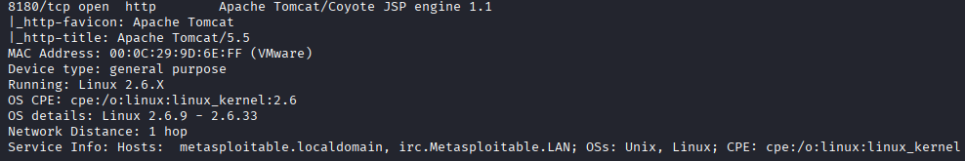

Remediation:
Action recommended:
1. Comment out/remove AJP connector in conf/server.xml or bind to localhost.
2. Remove or restrict manager webapp; require strong unique credentials.
3. Upgrade Tomcat to supported version.
Verification: ss -tulpn | egrep ':(8009|8180)'; curl -I http://<target>:8180/manager/html -s -o /dev/null -w "%{http_code}\n"

6 - MySQL 5.0 and PostgreSQL 8.3 exposed
Target: 192.168.137.129:3306,5432
Severity: High
Description:
Old DB versions; verify weak/default credentials and database access controls.

Evidence:
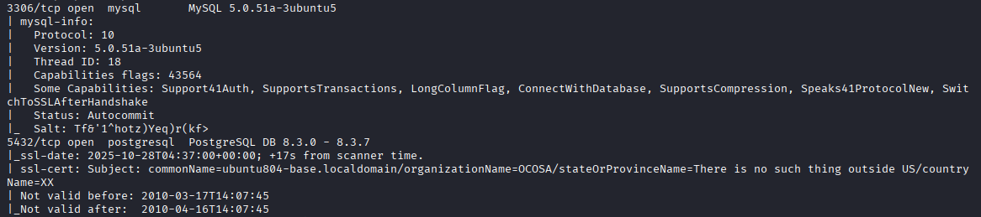

Remediation:
Action recommended (MySQL):
1. Run sudo mysql_secure_installation and enforce root/pass rotation
2. Set bind-address=127.0.0.1 in my.cnf and restart MySQL
3. Remove anonymous users and test DB
Verification: ss -tulpn | grep 3306; mysql -h127.0.0.1 -u root -p
Action recommended (PostgreSQL):
1. Set listen_addresses='localhost' and update pg_hba.conf to restrict access.
2. Restart postgresql; verify only local binds.

7 - UnrealIRCd / IRC (6667)
Target: 192.168.137.129:6667
Severity: Medium
Description:
UnrealIRCd found; known historical backdoors exist for some versions - check for known CVEs.

Evidence:

Remediation:
Action recommended:
1. Remove or upgrade the IRC server: sudo apt-get remove --purge unrealircd -y
2. If required, patch to vendor-supplied secure version and restrict access with firewall rules.
Verification: ss -tulpn | grep 6667

8 - Vulnerable JS library + Missing Anti-CSRF tokens
Target: Web application on 192.168.137.129
Severity: High (web application security)
Description:
OWASP ZAP reported absence of Anti-CSRF tokens, vulnerable JS libs, CSP not set, missing clickjacking header and application error disclosure. Manual verification required to confirm exploitability.

Evidence:
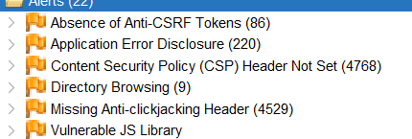

Remediation:
Action recommended:
1. Update/patch vulnerable JS libs (replace vendor files or use CDN with SRI)
2. Implement server-side Anti-CSRF tokens for all state-changing requests
3. Add CSP headers and other security headers (see Apache section)
Verification: Re-run ZAP to confirm Anti-CSRF tokens present and that vulnerable libs are gone

9 - Bind 9.4.2 (DNS)
Target: 192.168.137.129:53
Severity: Medium
Description:
Old BIND version exposes DNS services; version disclosure present.

Evidence:
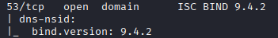

Remediation:
Action recommended:
1. Upgrade BIND package
2. Restrict recursion and zone transfers in named.conf.options:
options {
recursion no;
allow-recursion { 127.0.0.1; 192.168.137.0/24; };
allow-transfer { none; };
version "not available";
};
3. Restart bind: sudo systemctl restart bind9
Verification: dig @<target> any; dig axfr <zone> @<target> (should be refused)

10 - Metasploitable bind shell service (1524)
Target: 192.168.137.129:1524
Severity: Critical
Service: xinetd (configured to spawn bind shell)
Process ID (PID): 5110

Description:
A bind shell was discovered on TCP port 1524, hosted by the `xinetd` process. This backdoor provides remote root-level access without authentication.

Evidence:
Commands executed:
sudo ss -tulpn | grep 1524 | tee ~/scans/target_ss_1524.txt
sudo lsof -i -P -n | grep LISTEN | grep 1524 | tee ~/scans/target_lsof_1524.txt
sudo ps -o pid,uid,gid,cmd -p 5110 | tee ~/scans/target_proc_5110.txt

Raw outputs:
# ~/scans/target_ss_1524.txt
0 tcp 64
*:1524
users: (("xinetd", 5110,12))

# ~/scans/target_lsof_1524.txt
xinetd 5110 root 12u IPv4 12878
TCP *:1524 (LISTEN)

# ~/scans/target_proc_5110.txt
PID UID GID CMD
5110 0 0 /usr/sbin/xinetd -pidfile /var/run/xinetd.pid -stayalive -inetd_compat

Interpretation:
- xinetd process (PID 5110) is listening on TCP port 1524.
- The process runs as root (UID 0), confirming high privilege.
- This is a non-interactive backdoor listener and should not be present on production hosts.

Attacker-side verification:
nc -vz 192.168.137.129 1524 2>&1 | tee ~/scans/nc_connect_1524.txt
Output:
192.168.137.129: inverse host lookup failed: Host name lookup failure
(UNKNOWN) [192.168.137.129] 1524 (ingreslock) open

CVSS v3.1 Vector and Score:
CVSS:3.1/AV:N/AC:L/PR:N/UI:N/S:U/C:H/I:H/A:H (Base: 9.8)

Remediation Steps (Host-Side):
Immediate Mitigation:
sudo iptables -I INPUT -p tcp --dport 1524 -j DROP
sudo iptables -L INPUT -n --line-numbers | grep 1524

Exploiting the Vulnerabilities

- vsftpd access
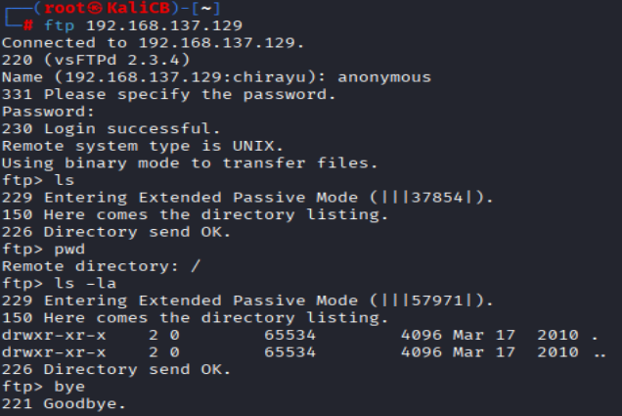

- Apache header banner

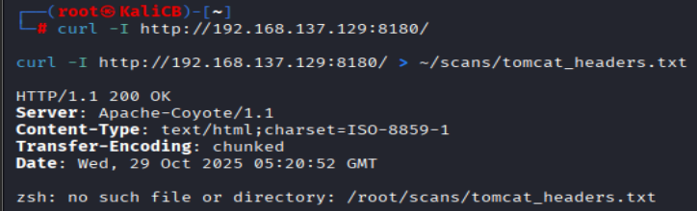

- Blindshell

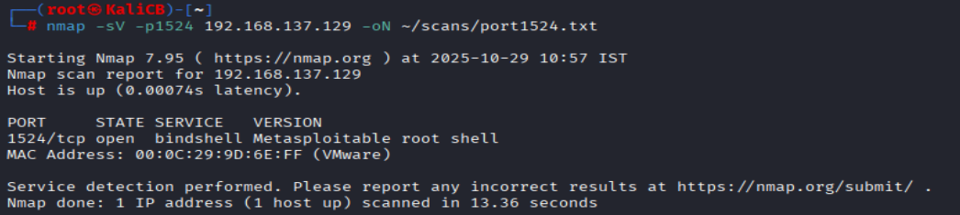
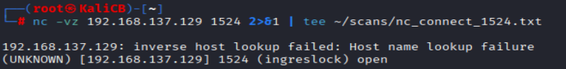
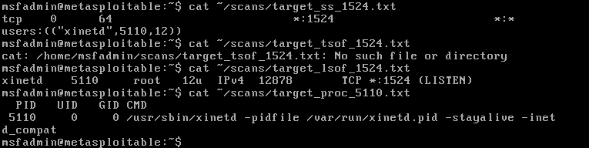

Risk, CVSS, & Prioritization
1.Estimated/Verified CVSS (NVD CVSS v3.1): CVSS:3.1/AV:N/AC:L/PR:N/UI:N/S:U/C:H/I:L/A:L — Base Score: 8.6 (High)
Rationale: Anonymous FTP allows disclosure of sensitive files and potential file upload.

2. Estimated/Verified CVSS (NVD CVSS v3.1): CVSS:3.1/AV:N/AC:L/PR:L/UI:N/S:U/C:H/I:H/A:N — Base Score: 8.3 (High)
Rationale: Outdated OpenSSH version may allow credential or algorithm weaknesses; requires low privilege to exploit.

3. Estimated/Verified CVSS (NVD CVSS v3.1): CVSS:3.1/AV:N/AC:L/PR:N/UI:N/S:U/C:H/I:L/A:N — Base Score: 8.2 (High)
Rationale: Cleartext protocols (telnet/rsh) transmit credentials in plaintext.

4. Estimated/Verified CVSS (NVD CVSS v3.1): CVSS:3.1/AV:N/AC:L/PR:N/UI:R/S:U/C:L/I:L/A:N — Base Score: 5.4 (Medium)
Rationale: Directory browsing and info disclosure.

5. Estimated/Verified CVSS (NVD CVSS v3.1): CVSS:3.1/AV:N/AC:L/PR:N/UI:N/S:U/C:H/I:H/A:H — Base Score: 9.8 (Critical)
Rationale: Tomcat/AJP exposure with potential for RCE on vulnerable versions.

6. Estimated/Verified CVSS (NVD CVSS v3.1): CVSS:3.1/AV:N/AC:L/PR:N/UI:N/S:U/C:H/I:H/A:H — Base Score: 9.0 (Critical)
Rationale: Databases with weak/default credentials enable complete data compromise.

7. Estimated/Verified CVSS (NVD CVSS v3.1): CVSS:3.1/AV:N/AC:L/PR:N/UI:N/S:U/C:L/I:L/A:L — Base Score: 7.3 (Medium)
Rationale: Information disclosure via IRC service banner.

8. Estimated/Verified CVSS (NVD CVSS v3.1): CVSS:3.1/AV:N/AC:L/PR:N/UI:R/S:U/C:L/I:L/A:N — Base Score: 5.4 (Medium)
Rationale: Missing anti-CSRF tokens; lower impact unless chained with auth bypass. If vulnerable JS leads to XSS/RCE impact would be higher.

9. Estimated/Verified CVSS (NVD CVSS v3.1): CVSS:3.1/AV:N/AC:H/PR:N/UI:N/S:U/C:N/I:N/A:N — Base Score: 3.1 (Low)
Rationale: DNS server version disclosure - low direct impact but useful for fingerprinting.

10. Estimated/Verified CVSS (NVD CVSS v3.1): CVSS:3.1/AV:N/AC:L/PR:N/UI:N/S:C/C:H/I:H/A:H — Base Score: 9.8 (Critical)
Rationale: Bind shell accessible remotely with root privileges (scope change), full compromise.

11. Estimated/Verified CVSS (NVD CVSS v3.1): CVSS:3.1/AV:N/AC:L/PR:N/UI:N/S:C/C:H/I:H/A:H — Base Score: 9.8 (Critical)
Rationale: Bind shell accessible remotely with root privileges (scope change), full compromise.
CVSS vectors and scores added on 2025-10-29 07:55 IST (estimates based on lab evidence).

Matrix

Likelyhood/impact | Low | Medium | High
Low | DNS version disclosure (BIND 9.4.2) | Outdated SSH | Vulnerable JS
Medium | Anonymous FTP | Apache 2.2.8 directory listing | MySQL/PostgreSQL exposure
High | Telnet/RSH cleartext credentials | Apache Tomcat5.5 vulnerabilities | Backdoor bind shell (port 1524)

Tools, Commands & Evidence
Commands used :
- nmap -sS -sV -sC -O -oA reports/nmap_full 192.168.137.129
- nikto -h http://192.168.137.129 -output reports/nikto.txt
- OWASP ZAP: explore site, run passive/active scan and export report

Difficulties Encountered
- Unable to create output files, faced errors with file and directory permissions when saving scan outputs
- Owasp Zap unstable session
- Nmap took long during OS/service detection, and some RPC services produced false positives
- Needed to troubleshoot Nikto file write errors caused by naming a directory meta2.txt instead of a file.
- ZAP scan outputs were large and repetitive (CSP Header Missing, Anti-CSRF, etc.), requiring manual filtering for relevant issues.

Key Learnings
- Recon (accurate version detection) is crucial for targeted testing.
- Combine automated scanners with manual verification (ZAP/Burp + manual test cases).
- Score vulnerabilities objectively with CVSS and prioritize with business impact overlay.

Appendix A: Nmap output (Shortened for hierarchy)
Starting Nmap 7.95 ( https://nmap.org ) at 2025-10-28 09:50 IST
Nmap scan report for 192.168.137.129
Host is up (0.00067s latency).
Not shown: 977 closed tcp ports (reset)
PORT STATE SERVICE VERSION
21/tcp open ftp vsftpd 2.3.4
22/tcp open ssh OpenSSH 4.7p1 Debian 8ubuntu1 (protocol 2.0)
23/tcp open telnet Linux telnetd
80/tcp open http Apache httpd 2.2.8 ((Ubuntu) DAV/2)
1524/tcp open bindshell Metasploitable root shell

Appendix B: OWASP ZAP findings (summary)
Reported issues from your ZAP scan (paste full ZAP report here):
- Absence of Anti-CSRF Tokens
- Application Error Disclosure
- Content Security Policy (CSP) Header Not Set
- Directory Browsing
- Missing Anti-clickjacking Header
- Vulnerable JS Library

Remediation Recommendations (high level)
- Remove anonymous FTP or restrict to authenticated users; upgrade/replace vsftpd; restrict FTP to secure alternatives (SFTP).
- Disable telnet/rsh/rexec and replace with SSH with key-based auth. Rotate weak host keys and upgrade OpenSSH.
- Patch Apache, Tomcat, MySQL, PostgreSQL to supported versions; disable unnecessary modules and remove default/example apps.
- Add security headers: Content-Security-Policy, X-Frame-Options, X-Content-Type-Options; implement Anti-CSRF tokens and server-side input validation.
- Apply principle of least privilege to database accounts and require strong passwords; remove sample databases.
- Run authenticated scans (OpenVAS/Nessus) and map CVEs to findings; compute CVSS for each issue and prioritize fixes.

Appendix C — Nikto Scan Findings
Command used: sudo nikto -h http://192.168.137.129 2>&1 | tee ~/scans/meta2.txt

Summary of Findings
- Server: Apache/2.2.8 (Ubuntu) DAV/2
- Retrieved X-Powered-By header: PHP/5.2.4-2ubuntu5.10
- Missing security headers: X-Frame-Options (anti-clickjacking), X-Content-Type-Options (nosniff)
- Apache 2.2.8 is outdated and may contain multiple CVEs; upgrade recommended
- mod_negotiation MultiViews enabled; alternatives for 'index' found (index.php)
- HTTP TRACE method is active (Cross-Site Tracing risk)
- phpinfo() accessible at /phpinfo.php — sensitive server info exposure
- Directory indexing found at: /doc/, /test/, /icons/
- phpMyAdmin present in /phpMyAdmin/ and related files (changelog, README)
- Potential disclosure via PHP-specific query strings (OSVDB-12184)
- Default apache files (icons/README) and potential ETag inode disclosure noted
- 27 items reported; 8910 requests; scan duration ~21 seconds

Remediation Recommendations
1. Patch/upgrade Apache to a supported 2.4+ release and apply OS security updates:
sudo apt update && sudo apt -y upgrade
sudo apt-get install --only-upgrade apache2

2. Remove or disable phpinfo() scripts and any development/test pages (phpinfo.php, /test/, /doc/):
sudo rm -f /var/www/html/phpinfo.php
sudo rm -rf /var/www/html/test /var/www/html/doc

3. Disable HTTP TRACE:
In Apache config (e.g., /etc/apache2/apache2.conf or virtualhost):
TraceEnable Off
Then restart Apache:
sudo systemctl restart apache2

4. Disable MultiViews if unnecessary:
In site config or .htaccess:
Options -MultiViews
Restart Apache.

5. Add security headers via mod_headers (enable mod_headers):
sudo a2enmod headers
Add to Apache config or virtualhost:
Header always append X-Frame-Options SAMEORIGIN
Header set X-Content-Type-Options nosniff
Header set X-XSS-Protection "1; mode=block"

6. Restrict phpMyAdmin to admin hosts only:
In apache conf for phpMyAdmin:
<Directory /usr/share/phpmyadmin>
Require ip 192.168.137.128
</Directory>
Or use firewall rules to restrict access.

7. Remove default documentation and icons:
sudo rm -rf /usr/share/doc/apache2 /var/www/icons /usr/share/apache2/icons

8. Re-run Nikto and OWASP ZAP after remediation to verify issues are resolved.

